**Uncertainty evaluation among CA and it’s alternatives for Single Country/Circle:**

In every section, we have presented 10 examples of circles with different percentages of uncertainty/CA for user perception. Then we have added a questionnaire section with five circles one after another and the task is defined as to determine the uncertainty based on prior perception for each circle and write the corresponding answer in percentage (x%) afterwards.

**Ca** Evaluation section**:**

**Examples in % for user perception:**  
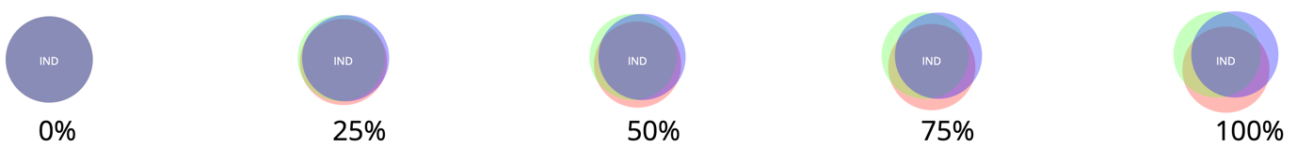

**Questionnaire:**

Q1. Estimate the uncertainty for the following circle in the range 10% to 100%

Answer:

Q2. Estimate the uncertainty for the following circle in the range 10% to 100%

Answer:

Q3. Estimate the uncertainty for the following circle in the range 10% to 100%

Answer:

Q4. Estimate the uncertainty for the following circle in the range 10% to 100%

Answer:

Q5. Estimate the uncertainty for the following circle in the range 10% to 100%

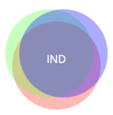

Answer:

**ca-static** Evaluation section:

**Examples in % for user perception:**

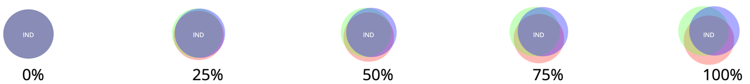

**Questionnaire:**

Q1. Estimate the uncertainty for the following circle in the range 10% to 100%

Answer:

Q2. Estimate the uncertainty for the following circle in the range 10% to 100%

Answer:

Q3. Estimate the uncertainty for the following circle in the range 10% to 100%

Answer:

Q4. Estimate the uncertainty for the following circle in the range 10% to 100%

Answer:

Q5. Estimate the uncertainty for the following circle in the range 10% to 100%

Answer:

**Blur** evaluation section**:**

**Examples in % for user perception:**

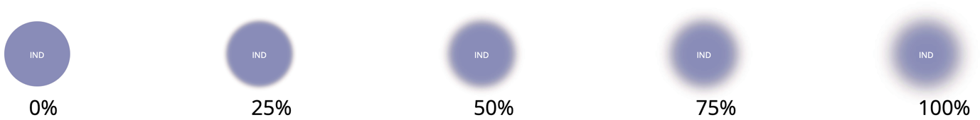

**Questionnaire**:

Q1. Estimate the uncertainty for the following circle in the range 10% to 100%

Answer:

Q2. Estimate the uncertainty for the following circle in the range 10% to 100%

Answer:

Q3. Estimate the uncertainty for the following circle in the range 10% to 100%

Answer:

Q4. Estimate the uncertainty for the following circle in the range 10% to 100%

Answer:

Q5. Estimate the uncertainty for the following circle in the range 10% to 100%

Answer:

**Noise** evaluation section:

**Examples in % for user perception:**

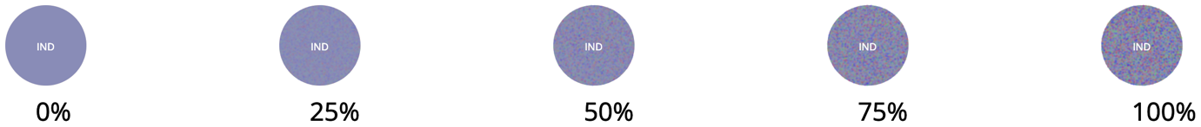

**Questionnaire:**

Q1. Estimate the uncertainty for the following circle in the range 10% to 100%



Answer:

Q2. Estimate the uncertainty for the following circle in the range 10% to 100%



Answer:

Q3. Estimate the uncertainty for the following circle in the range 10% to 100%

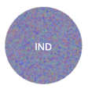

Answer:

Q4. Estimate the uncertainty for the following circle in the range 10% to 100%



Answer:

Q5. Estimate the uncertainty for the following circle in the range 10% to 100%



Answer:

**Bubble Chart of three Countries  
  
**

Figure-3: Bubble chart with three countries

**Description:** This chart is drawn with three countries only to gradually introduce the difference to the user. Since Figure-2 had only one country so there was nothing to compare side by side but here in Figure-3 user can compare both uncertainty and number of infections count.

1. Brazil (BRA) shows maximum uncertainty among three.

|  |  |  |  |  |
| --- | --- | --- | --- | --- |
| Strongly  agree | Partially  agree | Neither agree nor disagree | Partially  disagree | Strongly  disagree |

1. Difference of uncertainty between United States (USA) and Brazil (BRA) in terms of pixel.

|  |  |  |  |  |
| --- | --- | --- | --- | --- |
| 2px | 5px | 7px | 10px | 15px |

1. Brazil (BRA) has second maximum number of infections.

|  |  |  |  |  |
| --- | --- | --- | --- | --- |
| Strongly  agree | Partially  agree | Neither agree nor disagree | Partially  disagree | Strongly  disagree |

1. Based on Figure-3 uncertainty is irrelevant to the number of infections because India has maximum count but not maximum uncertainty.

|  |  |  |  |  |
| --- | --- | --- | --- | --- |
| Strongly  agree | Partially  agree | Neither agree nor disagree | Partially  disagree | Strongly  disagree |